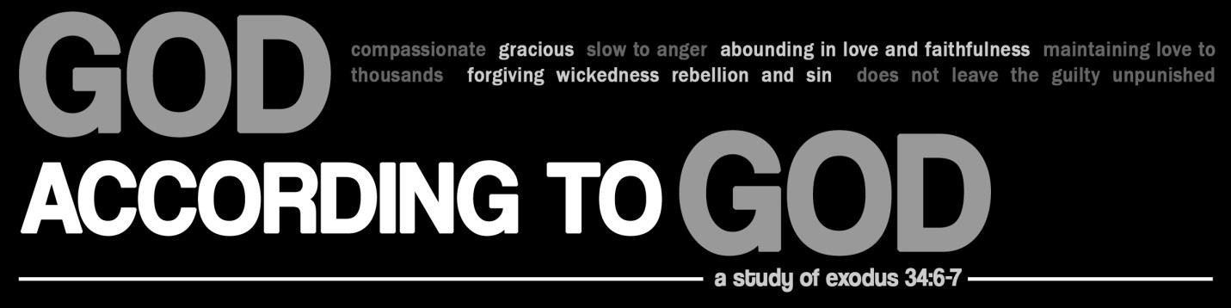

Lesson 3

Bring two blank pieces of paper to your classroom. These will be used in the opening exercise.

Hand the two blank pages to two different volunteers. Ask one to make a paper airplane, and ask the other to make a paper boomerang. (The one making a boomerang will probably not be successful, and this will help make the point.)

As they begin their tasks, discuss with the class the differences between the two.

How easy is it to make a paper airplane?
How easy do you think it would be to make a paper boomerang?
How do the two differ in function?

Ask the two volunteers to give their creations a test run.

In Nehemiah 8, the people of Israel are in the middle of resettling in the land after being released from captivity. Ezra, a leader and a teacher, brings out the “Book of the Law of Moses”4 (Neh 8:1) and reads it in front of the people “from daybreak till noon” (8:3).

The people’s response is to weep (8:9), although Ezra and Nehemiah encourage a day of
celebration instead of mourning (8:10).

The people begin to follow the words contained in the “Book of the Law,” beginning with
celebrating certain festivals (8:18).

Later that month, the Israelites separate themselves from any foreigners who happen to be
living with them, and they begin to confess their sins and their ancestors’ sins (9:2-3).

4 This is an unspecified part of the Pentateuch (Gen-Deut).

During this event, some Levites stand up and begin retelling the story of God and the nation of
Israel.

Read Nehemiah 9:7-15

• The story of God and Israel begins with God calling Abraham and making a covenant with him (7-8).
- The Levites make a judgment about God: “You have kept your promise because
you are righteous” (8b).
• Next, the Levites tell about the exodus from Egypt (9-12).
- God was moved by the Israelites’ suffering, and so God “sent signs and wonders against Pharaoh” and the leaders of Egypt. By doing this, God made a name for himself. (9-10).
- o God divided the sea so Israel could pass through, but God threw the Egyptians into the sea and they drowned (11).
- o God faithfully led his people with a cloud and with fire (12).
• After the exodus, God made a covenant with his people at Mount Sinai, which included regulations for how God wanted his people to live (13-14).
•

Overall, how do the Levites portray God in this passage?

Read Nehemiah 9:16-21

• Israel’s response is less than admirable. They “became arrogant and stiff-necked,” and they disobeyed God’s commands (16).
• Not only did they refuse to listen, but they “failed to remember” God’s past miracles
(17).
• They wanted to return to slavery (17b).
• God, however, did not abandon them.
o Because God is a “forgiving God, gracious and compassionate, slow to anger and abounding in love,” he didn’t desert Israel (17c).
o He was faithful to Israel even when they made a golden calf to worship as the one who brought them out of Egypt (18).
o But God’s great compassion meant that God stayed faithful, even when Israel did
not.
▪ God continued to guide them with the cloud and fire (19).
▪ God continued to give them food, water, and his spirit (20).
▪ God continued to provide clothing, and God kept their feet from becoming swollen, despite all their walking (21b).
▪

How do the Levites portray their ancestors?
How do the Levites portray God’s response?
Isn’t God just being a doormat by continuing to be compassionate? Isn’t he just giving tacit approval to the people’s rebellion? If not, why not?

Read Nehemiah 9:22-30

• These verses tell another cycle of the story of God and Israel.
- God gives land and kingdoms to Israel (22-25).
- The people, in spite of these blessings, rebel by killing God’s prophets (23).
- God delivers Israel over to enemies (27a).
- Israel cries out because of their defeat and oppression (27b).
- God’s compassion moves him to send deliverers and rescuers to Israel (27c).
- Israel repeats the cycle (28-30).

Read Nehemiah 9:31

• The Levites issue another verdict about God: “…in your great mercy you did not put an end to them or abandon them, for you are a gracious and merciful God” (31).

This is another cycle of the people sinning and God. Again, is God a doormat? Does he not care about sin?

What the Levites have shown is that God is relentlessly faithful. In this story, the Levites do tell about God’s punishment (Neh 9:27a, 28a). God does not let sinfulness go completely unpunished.

But God seems to always come back to his people when they cry out (9:27b, 28b). In this way, we can picture God as a boomerang, not a paper airplane.
- Being a paper airplane is easy. Deserting is easy. Leaving sinful people to reap their consequences is easy.
- Being a boomerang is hard. Coming back is hard. Forgiving sin is hard. Showing

Does this match your picture of God? Why or why not?
How can we be sure we don’t mistake forgiveness and mercy for weakness and approval of sin?
If God has forgiven in this way throughout history, what might that say about our capacity and need to forgive? (Think of the parable of the unforgiving servant in Matt 18:21-35.)

Remember this: when you sin, you stand in a long lineage of sinners. Your problems are not new. Your rebellion is not a surprise to God.

And you are not the first to be forgiven. You stand in a long lineage of undeservedly forgiven people.

Because of that, let us be thankful to our faithful God, and let us be a people who are quick to forgive and to return. Let us be boomerangs who return even when it is hard.

As a class, say Exodus 34:6-7 out loud together:

“ The Lord, the Lord, the compassionate and gracious God, slow to anger, abounding in love and faithfulness, maintaining love to thousands, and forgiving wickedness, rebellion and sin. Yet he does not leave the guilty unpunished; he punishes the children and their children for the sin of the parents to the third and fourth generation.”

Now say Numbers 14:18 together:

“ The Lord is slow to anger, abounding in love and forgiving sin and rebellion. Yet he does not leave the guilty unpunished; he punishes the children for the sin of the parents to the third and fourth generation.”

Now say Nehemiah 9:17b together:

“…you are a f orgi v i ng God, graci ous and compass i onat e, s low to an ger a nd aboun ding i n l ove. The ref ore
you did not d esert t hem…”

Read Psalms 86, 103, and 145 for next week.

